Melinda Ong

CPE 329-01

Assignment 2: Datasheet Fun

1. ***Create a memory map for Code and Peripheral address spaces of the MSP432P401R.***

|  |
| --- |
| Peripheral: 0x4000_0000-0x5FFF_FFFF |
|  |
| Code: 0x0000_0000-0x1FFF_FFFF |

1. ***How many internal oscillators does the MSP432 have?***   
   Two (DCO and VLO)
2. ***How many timers does the MSP432P401R have? What size are the timers?***  
     
   Six total (four 16-bit and two 32-bit)
3. ***What is the maximum sampling rate of the analog to digital converter on the MSP432P401R?***  
   1 Msps
4. ***What is the equation for determining the digital output of the analog to digital converter when operating in single-ended mode on the MSP432?***   
     
   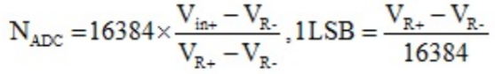
5. ***Which register is the primary mechanism for changing power modes on the MSP432?***   
     
   PCM Control 0 (PCMCTL0) register
6. ***When the temperature goes up, does the general I/O output current from the MSP432 go up or down?***   
     
   The low-level current goes down and the high-level current goes up as temperature increases.
7. ***The high drive I/O on the MSP432P401R produces more current by a factor of X. Estimate X according to the datasheet.***  
     
   5.5